Simple multiplication
DESCRIPTION:
Every budding hacker needs an alias! The Phantom Phreak, Acid Burn, Zero Cool and Crash Override are some notable examples from the film Hackers.
Your task is to create a function that, given a proper first and last name, will return the correct alias.

SOLUTION:
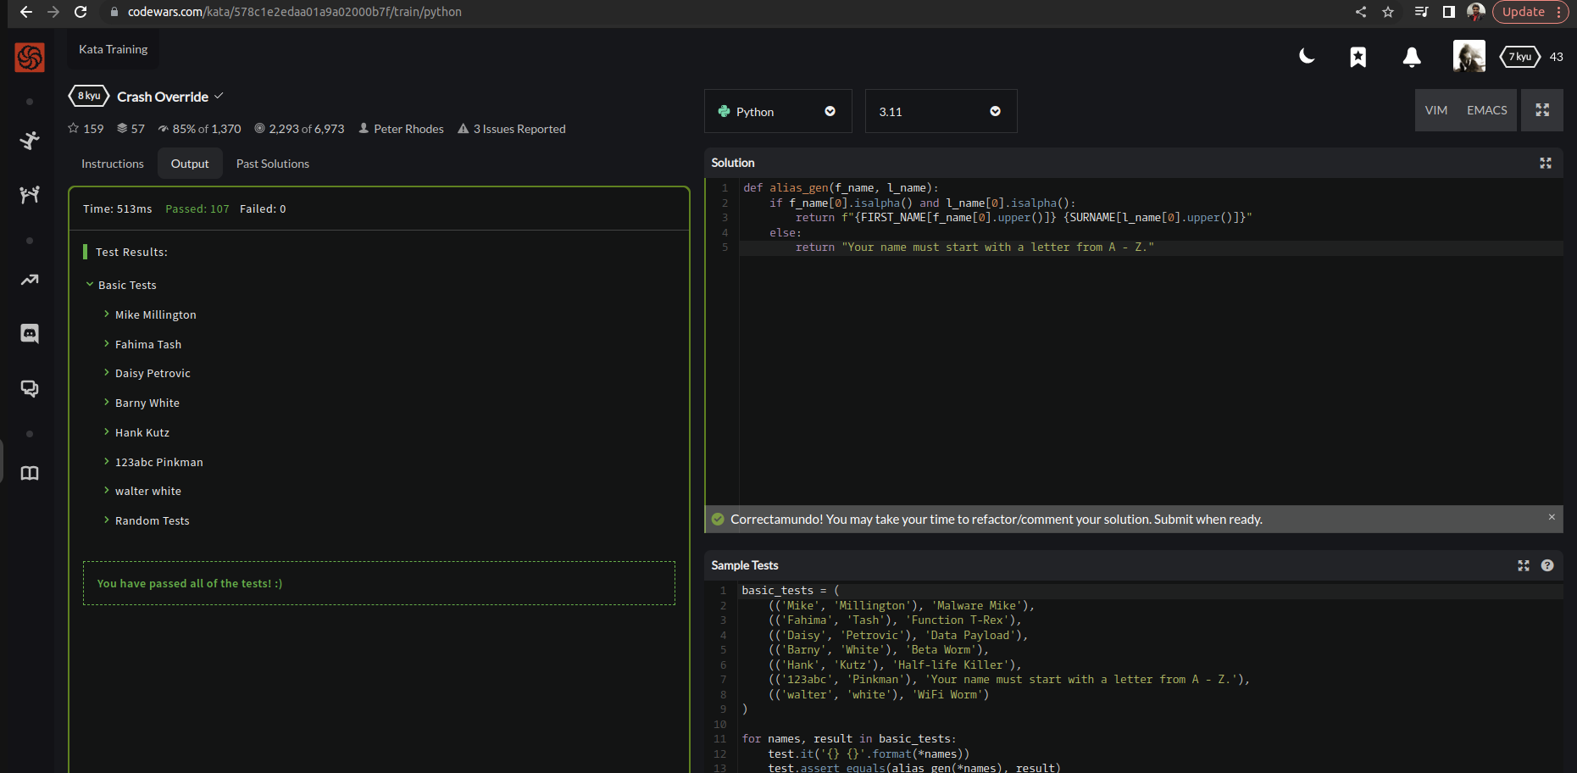

EXPLANATION:
We’re asked to print correct first & last name with exact alias. Therefore, for printing correct alias we need to use isalpha() builtin method which mainly returns true if all the characters are alphabet letters (a-z) by considering 0th index of our given parameters. Moreover If the first character of either of the names given to the function is not a letter from A TO Z, you should return “YOUR NAME MUST START WITH A LETTER FROM A TO Z.

